SAP GRC

1. Which ticketing tool you are using? Why it is used and how many tickets you will get per day and how many you resolved a day?
- We are using Snow ticketing tool. Snow is software which provides solutions for the tickets.
- Ticket means a problem. There are many ticketing tools are available. Ex: REMEDY, Snow.
- Service Now is used for create an incident and resolve it.
- We are getting 10 to 15 tickets per day. I am going to resolve 7 tickets per day.

Prioritization of Incidents: ITIL (Information Technology Infrastructure Library) uses three metrics for determining the order in which incidents are processed.
- Impact: The effect an incident has on business.(1-High, 2-Medium, 3-Low)
- Urgency: The extent to which the incident's resolution can bear delay. (Same as above)
- Priority: How quickly the service desk should address the incident. (1-Critical, 2-High, 3-Moderate, 4-Low, 5-Planning).

SEVIARITIES ABOUT TICKETS:

SERV 1: Need to resolve tickets in 0-4 hours
SERV 2: Need to resolve tickets in 0-8 hours
SERV 3: Need to resolve tickets in 3 working days.
Production Support: Should be on call support.
Situation Manager: Makes everyone to attend on call.
Q) When you are On Call Support when you get Severity 1 ticket, How do you take action?
- Firstly open the ticket
- Read the message what the problem is about
- Login to targeted Servers.
- Check Logs depending on Error.
- Propagates first-hand information to STAKE HOLDER (DUTY MANAGER).
- Sit on Issue, fix it, and Close it.

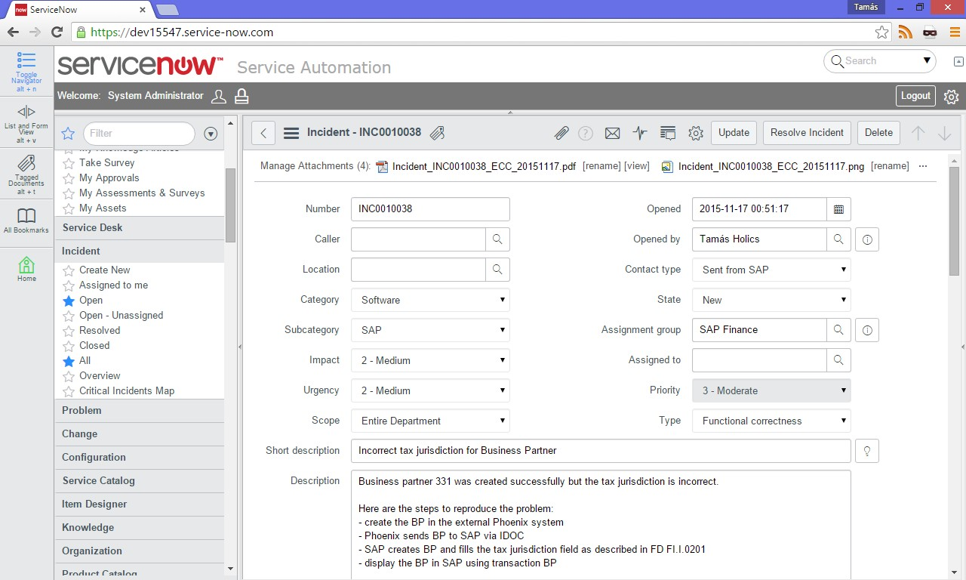

2. Why is GRC? Instead of it we can use Security right?

Connector Configuration
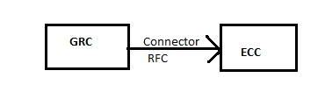
ECC_RFC_USER (Communication User)
- A User ID needs to be created in ECC for the RFC setup, with required authorizations.
Connectors:
- Connectors are the links between SAP Access Control tools and target systems to fetch data into the SAP Access Control System.
- Connector is nothing but RFC connection to which you are connecting GRC system to plug in systems to getting data about user authorization or to perform risk analysis.
- Connectors are used for communication between GRC system and target systems where GRC plug-in is deployed.
- In SAP GRC Connectors and Connector types are defined globally.
- Create and maintaining connector settings from a SAP GRC system to any SAP / Non-SAP systems to get different data, execute risk analysis or create and provide for roles.

Connector Types:
As a part of creating connectors, you need to define connection types and map the actual connectors with the connection types.
Different types of connections that are available to use in SAP Access Control are…

- SAP
- LDAP
- SPML (Service Provisioning Markup Language)
- FILE
- EP
- LOCAL

Connector Groups:
- Connector group is a logical group to use common rule set. Like standard you can create your own group map with rule set, whoever connector defined in that group will use the same rule set.
- So, to clarify: If I have ECC, HR, SRM, CRM systems in my landscape and I want to use same rule set across these systems I will use a Connector Group.
Connector Group Types:
- Logical Group:

- Logical group consists of the systems that are logically the same.
- Ex: All SAP ERP systems or Oracle systems.

- Cross-system Group:

- Cross system group consists of the systems with different environments.
- Ex: SAP CRM, SAP SRM, LDAP, and Oracle applications.
GRC Landscape

Production
Quality
Dev

Production
Dev

GRC prod

BW prod
ECC prod
S4 Hana Prod

GRC prod

BW D/Q/P
ECC D/Q/P
S4 Hana DQP

GRC Dev

BW Non
ECC Non prod
S4 Hana Prod

Steps for Connector Configuration:
Summary:
- SPRO IMG GRC Common Component SettingsIntegration Framework

- Create Connectors
- Maintain Connectors and Connection types
- Maintain Connection Settings

- SPRO IMG GRC Access Control

- Maintain Connector Settings
- Maintain Mapping for Actions & Connector Groups

- Create Connectors: (SM59)

RFC Connections ABAP Connections Create Button

RFC Destination: GRCCLNT100
Connection Type: 3 ABAP Connections
Description 1, 2, 3: RFC Destination to GRC Client 100

Technical Settings Tab:
- Target Host : INDIA and Enter button System No: 02
Logon & Security TAB
  - Language: EN
  - Client: 100
  - User: SUDHA
  - Password: india123
RFC Destination name and Client logical system name must be same

Testing RFC Connection:
- Clicking Connection Test button and Remote Logon button. (Or)
- Utilities ------- Test ----- Connection Test and ----- Authorization Test.
Start SAP ECC Server…
RFC Connections ABAP Connections Create Button
RFC Destination: T90CLNT090
Connection Type: 3 ABAP Connections
Description 1: RFC Destination to ECC Client 800

Technical Settings Tab  Target Host: india.server.com  System Number: 02  Gateway Host: india.server.com  Gateway service: sapgw02 | Logon & Security TAB  Language: EN  Client: 800  User: SAPUSER  Password: india123

NOTE 1:

You can find Gateway Host Name and Gateway service details, in
TCODE: SMGW
Menu Go to Parameter Display

NOTE 2:
- Connection Test fails means need to check Technical settings tab Host name and System number.
- Authorization Test fails means need to check Logon Security Tab user name and Password.

- Maintain Connectors and Connection types:

2. a. Define Connectors
2. a. I. Define Subsequent Connectors
2. b. Define Connector Groups
2. b. I. Assign Connector Groups to Groups Types
2. b. II. Assign Connectors to Connector Groups
2. a. Define Connectors:
- Double Click on Define Connectors on left side and
- Click on New Entries
Target Connector | Connection Type | Source Connector | Logical Port | Max No. of BG WP
GRCCLNT100 | SAP | GRCCLNT100 | GRCCLNT100 | 3
T90CLNT090 | SAP | T90CLNT090 | T90CLNT090 | 3
 | From data point of view which system is consider to be has Source. Both are same as Source and Target. |  | The port through which data exchange will be done b/w ECC & GRC

2. a. I. Define Subsequent Connectors:
    - If portal connectors are planned in your project, you need to maintain the subsequent connector definition.
    - Subsequent connector meant to maintain a logical port as an additional requirement to connect and get the data.
    - Double click on Define Connectors ------ Select an entry T90CLNT090and Double click on Define Subsequent Connector.
Note: Whenever we are going to Sub folder one entry has to be chosen from Main folder.
    - Subsequent Connectors are defined only for JAVA System not required for ABAP System.

2. b. Define Connector Groups:
    - Double Click on Define Connector Group ( left side)
    - Click on NEW ENTRIES
Connector Group | Connector Group Text | Con. Type
BUSINESS | Business Roles
SAP_CRM_LG | SAP CRM
SAP_ECC_LG | SAP ECCS | SAP
SAP_GRC_LG | SAP GRC Logical Group | SAP
SAP_R3_LG | SAP R3 | SAP
ABAP_GROUP | ABAP Group | SAP
JAVA_GROUP | JAVA Group | EP

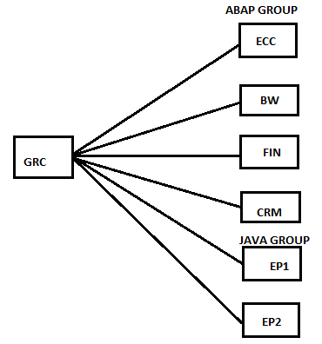

2. b. I. Assign Connector Groups to Groups Types:
- Select SAP_GRC_LG and double click on Assign Connector Groups to Group Types ---------New Entries
- Connector Group Type: Logical Group and Click on SAVE.
- The groups created in the earlier step should be declaring here as Logical Group.

2. b. II. Assign Connectors to Connector Groups:
- Select SAP_GRC_LG Double Click on Assign Connectors to Connector Groups
- Click on New Entries
Target Connector | Connection Type
GRCCLNT100 | SAP
T90CLNT090 | SAP

- Click SAVE

- Maintain Connection Settings:

- The integration scenario functionality is designed to work with different applications from SAP Access Control.
- You can use integration scenarios to define what kind of connector you want, how you want to maintain the connector, and how to technically deal with the connectors and connection types for each SAP Access Control tool.

Integration Scenario | Text
AM | Automatic Monitoring (Process Control)
AUTH | Authorization Management (ARA)
PROV | Provisioning (ARM)
ROLMG | Role Management (BRM)
SUPMG | Super User Privilege Management (EAM)

- Ex: The AUTH Scenario is meant for the Access Risk Analysis tool of SAP Access Control to connect with the target system.

- Integration Scenario: AUTH
- Tick
Sub scenario definition
Sub Scenario | Sub Scenario Text
AUTH | Authorization Management

- Select AUTH, and click on Scenario-Connection type link (left side)
Scenario-Connection type Link
Con.Type | Connection Type Text | Class/Interface
FILE | File system for legacy extraction | CL_GRAC_AD_AUTH_MGMT_FILE
LDAP | LDAP Connectors | CL_GRAC_AD_AUTH_MGMT_LDAP
SAP | SAP System | CL_GRAC_AD_AUTH_MGMT_RFC
WS | Web service | CL_GRAC_AD_AUTH_MGMT_WS

- Select SAP, and click on Scenario-Connector Link (left side)
- New Entries
Scenario-Connector Link
Target Connector | Con.Type | Connection Type Text
GRCCLNT100 | SAP | SAP System
T90CLNT090 | SAP | SAP System

- Click SAVE
- Do the same for rest of the integration scenarios like PROV, ROLMG, and SUPMG.

- Maintain Connector Settings:

- Click on New Entries

Dialog Structure
- Maintain Connector Settings  - Assign Attributes to the connector | Maintain Connector Setting
 | Target Connector |  | Appl Type | Environment | Path Id |  | PSS
 | T90CLNT090 |  | 1 | Production

- Maintain Mapping for Actions & Connector Groups:

5. a. Maintain Connector Group status
5. b. Assign default connectors to Connector Group

5. a. Maintain Connector Group status:
New Entries
Dialog Structure
- Maintain Connector Group Status  - Assign default connector to connector group  - Assign group field mapping  - Assign group parameter mapping | Maintain Connector Group Status
 | Connection Group |  | Active | Appl Type
 | SAP_R3_LG |  |  | 1
 | ABAP_GROUP |  |  | 2

5. b. Assign default connectors to Connector Group:
- Double Click on Assign default connectors to Connector Group.
- Click on New Entries

Dialog Structure
- Maintain Connector Group Status  - Assign default connector to connector group  - Assign group field mapping  - Assign group parameter mapping | Maintain Connector Group Status
 | Conn. Group |  | Action | Target Connector | Default
 | SAP_R3_LG |  | 1 | T90CLNT090
 | SAP_R3_LG |  | 2 | T90CLNT090
 | SAP_R3_LG |  | 3 | T90CLNT090
 | SAP_R3_LG |  | 4 | T90CLNT090
 | SAP_R3_LG |  | 5 | T90CLNT090

- If the Connector Group has more than one system, than this step has to be repeated for every system under the connector group.
- Only one system can be defined as Default connector for one action under connector group.

Action List:

- Role Generation
- Role risk Analysis
- Authorization Maintenance
- Provisioning
- HR Trigger

Post Installation Steps

- Check for required Software components as mentioned below.
- Activate all the BC Sets related to *GRAC* and *MSMP* through T Code: SCPR20.
- Activate all the Services related to *GRAC* and *NWBC* through T Code: SICF.
- Activate all relevant Applications in the client.
- Workflow for Perform Automatic workflow customizing or SWU3.
- Workflow for Perform – Task specific customizing.

- Check for required Software components as mentioned below:

- GRCFND_A ======== GRC
- GRCPINW ======== ECC
- GRCPIERP ======== HR

- Login into SAP GRC ======= Systems ===== Status ==== SAP System Data ===== Component information.

- Activate all the BC Sets related to *GRAC* and *MSMP* using T Code: SCPR20:

- BC Set ====== *GRAC* click on Continue button ====== Select each BC Set ===== Click on “Activate BC Set (F7) symbol”. Or Menu BC Set Activate.
- BC Set Activated or not we can check through ============ Click on “Activation Logs symbol”.
- If we want to check BC Set details / delivered values ========= Click on “Overall View button (F6)”.
- To see list of Activated BC Sets === SE16 ===== SCPRACTP.

    - ARM ====== Access_Request (4 BC Sets)
    - ARA ====== Rule Set (12 BC Sets)
    - BRM ====== Role_MGMT (5 BC Sets)
    - EAM ====== SPM_CRITICALITY (01 BC Sets)

- Total BC Sets in *GRAC* = 22 BC Sets.
- Total BC Sets in *MSMP* = 3 BC Sets.

Use Expert mode for activation and make sure that you see the message Activation Successfully Completed.

- Activate all the Services related to *GRAC* and *NWBC* through T Code: SICF:

- T Code: SICF ===== Hierarchy Type: SERVICE
Service Name: *GRAC* / *NWBC*
And Click on Execute.
- Expand Node Defaults ====== SAP ===== BC === Web dynpro === SAP ====== Right click on each node ===== “Activate Service”.
And also
Default_host=== SAP === BC === Web Dynpro === SAP
Default_host === SAP === BC === Work flow === NWBC
Default_host === SAP === BC === NWBC
Defaults ====== SAP === GRC === NWBC

- Activate all relevant Applications in the client:

- SPRO ====== IMG ====== GRC ==== General Settings ===== Activate Applications in the Client.
Active applications in client
App | Active
GRC – AC
GRC – PC
GRC – RM

- Workflow for Perform Automatic workflow customizing or SWU3:

- SPRO ====== IMG ====== GRC ==== General Settings ===== Workflow ===Perform Automatic workflow customizing. Or SWU3.
- All entries inside this screen should be “GREEN”.
- If not Green ==== Take a screen shot ==== send to BASIS team and ask them to turn it has “Green”.
      - Maintain Runtime Environment
      - Maintain Definition Environment
      - Maintain Additional Settings and Services
      - Classify Tasks as General
      - Guided Procedures

- We have to activate all of the steps from this transaction individually at all the five sub-heading level to complete basic workflow engine related settings.

- Right click on each activity and Click on Execute Activity / Auto Customizing.
Or
- Select the Sub Activity under Main Activity ====== Click on Execute. ====== To activate all the items, you need to update WF-BATCH which is carrying Background Jobs.
T Code: SU01
User: WF-BATCH ===== Modify User
Change password to india123
Email: nvrsudhakara@gmail.com (Compulsory)
Profiles: SAP_ALL and SAP_NEW

- Workflow for Perform – Task specific customizing:

- SPRO ====== IMG ====== GRC ==== General Settings ===== Workflow === Perform Task specific customizing.
- Go to GRC folder and Click on “Assign agents”.
Select the task that is Blank ==== Attribute button
- Select General Task and Click on “Transfer” and

- Click on “Activate Event Linkage”.
- Expand all events started with “WS***” ====Click on “Detail view” ===== It opens “Properties of event Linkage”
Linkage status: No Errors

- Do the same for GRCAC subfolders also.

Emergency Access Management (EAM)
3. Why EAM?
- The purpose of EAM is to allow users to complete tasks outside their normal day to day responsibility (authorizations). Means never and rarely used T Codes required to users to resolve some production issues or critical &emergency access conditions.
SAP (Firefighter) -------- USER + Extra privilege’s.
- EAM component gives temporary access (24 Hours / 2 Days) to users when assigned for solving a problem by giving broad - regulated access which can be audited.
- This temporary access is monitored and recorded in the application.
- Emergency Access Management helps reduce your business downtime due to any authorization-related issues.
- The use of Emergency Access Management to manage and utilize firefighting activities centrally in GRC Access Control 10.0 application and also follow the channel for log files can be distributed to controllers and owners via workflow for additional approval.

Advantages/ Uses of EAM:
- EAM allow users to perform additional activities outside of their normal job function.
- Allow temporary access for users when they required resolving some business tasks but regulated access.
- This temporary access will monitor and reviewed by the FF Controllers.
Pre requisites:
- Never assign SAP_ALL profile to FFID; instead FFIDs are classified according to module wise like… FFDEV1, FFDEV2, FFDEV3 (OR) FFBI1, FFBI2, FFBI3………… these separate set of IDs are assigned with respective development access.
- If we assign SAP _ALL to FFID, then FFID becomes itself a risk.
Example:
If we assign Finance FFID with SAP_ALL, he will have the possibility of modifying the system and it is a risk.
- To handle extreme conditions beyond Development access, we create a FFID accessible to all teams with a role (Which is a copy of SAP_ALL Profile). These FFIDs will need highest approval (Senior Manager) and its usage is strictly monitoring.

4. Firefighter types or user types in GRC?
User Type | Responsibility | Role
Firefighter ID (ECC) | Extra privileged user ID. All activities performed are tracked for audit purpose. | SAP_GRAC_SPM_FFID
Firefighter (GRC) | Person who performs some additional activities by using a Firefighter ID. | SAP_GRAC_SUPER_USER_MGMT_USER
Firefighter ID Owner (GRC) | Person who owns the ID and has authority to assign firefighter IDs to others. | SAP_GRAC_SUPER_USER_MGMT_OWNER
Firefighter ID Controller (GRC) | Person who reviews the reason code/description and audit trail to ensure that access was used appropriately. The user can be notified when firefighter IDs are checked in/out and notified of all activities performed via email trigger. | SAP_GRAC_SUPER_USER_MGMT_CNTLR

- Fire Fighter:

- FF is a normal user requiring emergency access to perform extra activities.
- The user who requires emergency access.
- Ex: Mr. Rama is a user in SAP ERP System. Rama seeks additional access, so we will create a Fire Fighter User in GRC System (Rama Fire Fighter).
- So, Rama has to login to the GRC system and perform additional activities in ECC.

- Fire Fighter ID/Role:

- User ID with extra privileges; it can only be accessed in the GRC server using transaction GRAC_SPM. As per latest update from SAP 10.1 FFID user type either Dialog/ Service.
- Firefighting: The act of using a firefighter ID.
- Fire Fighter ID/Role will be created on Target SAP ERP System.
- Fire Fighter ID will be synchronized to the SAP GRC System.
- Fire Fighter ID will be added to the Fire Fighter using NWBC Setup work set.

Difference between FF and FFID:

- In order to perform/ handled an extraordinary situation FF (Normal user) requests for elevated access, which is assigned through FFID.
- We don’t assign FF access to Business users and only for Technical users we assign.
Rama FF
Rama
SAP GRC System
SAP ERP System

Fire Fighter ID/Role
Fire Fighter ID/Role
FF Owner
Fire Fighter Controller

- Fire Fighter Owner: (Manager of AP Team, GL Team)

- FFID Owners are responsible for maintaining Firefighter IDs and their assignment to Controllers and Firefighters.
- FF Owners are responsible to assign FFIDs to FFs and FF Controllers.
- FFID Owner is a person from respective modules (GL, AP and BASIS Manager) who approves assignment of FFID to FF.
- Create a user called Fire Fighter Owner in SAP GRC System.
- And Assign Fire Fighter Owner to Fire Fighter using NWBC Setup work set.

- Fire Fighter Controller: (Controls Team)

- Reviews and approves (if necessary) the log files generated by a firefighter.
- FFID Controller is responsible for monitoring and reviewing of activities done by FF by using FFID.(SM20 FF Audit Logs)
- As we provided fire fighter to the Rama, we have to monitor the Rama activities.
- Fire Fighter Controller is responsible to monitor the activities of Fire Fighter Users.
- Assign Fire Fighter to Fire Fighter Controller using NWBC Setup work set.
- Generally this person is from Controls Team, who reviews Audit logs against the Reason Codes and T Codes mentioned by FF before using his FFID access.
- FFID Controller can be notified in 3 ways.
- Email
- Workflow
- Log display

- Create the User IDs in ECC and GRC :

SAP ECC System: SU01
Firefighter ID
USER ID | RAMAFFID
TYPE | Service
Roles | SAP_GRAC_SPM_FFID

GRC System: SU01
Firefighter Firefighter Owner Firefighter Controller
RAMAFF | FFOWNER | FFCNTLR
Dialog | Dialog | Dialog
SAP_GRAC_SUPER_USER_MGMT_USER  SAP_GRC_FN_BASE  SAP_GRC_FN_BUSINESS_USER  SAP_GRC_NWBC | SAP_GRAC_SUPER_USER_MGMT_OWNER  SAP_GRC_FN_BASE  SAP_GRC_FN_BUSINESS_USER  SAP_GRC_NWBC | SAP_GRAC_SUPER_USER_MGMT_CNTLR  SAP_GRC_FN_BASE  SAP_GRC_FN_BUSINESS_USER  SAP_GRC_NWBC

- Declare FFID Owner and Controller:

NWBC -------- Setup ---------- Access Owners -------- Access Control Owners.

- Define FFID Owner & Controller for the FFID in GRC system:

NWBC --------- Setup --------- Super User Assignment -------- Owner
NWBC --------- Setup --------- Super User Maintenance ------- Controllers

- Define Reason codes:

NWBC --------- Setup --------- Super User Maintenance -------- Reason Codes.

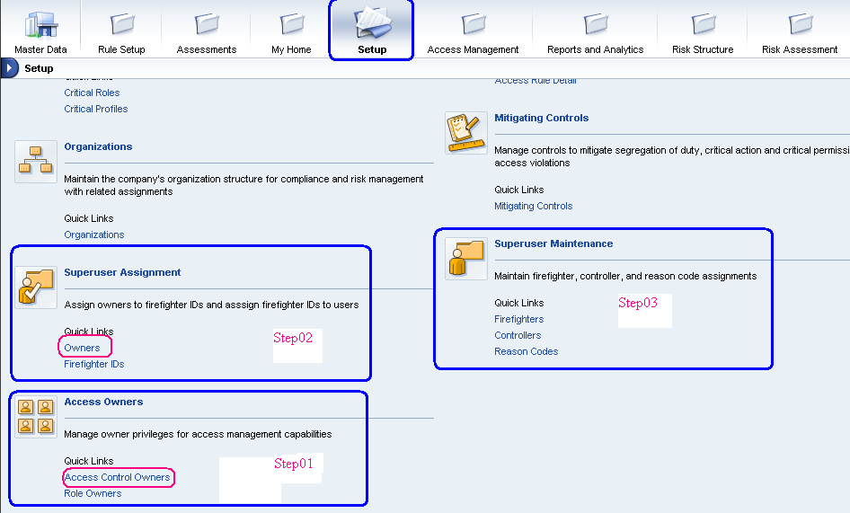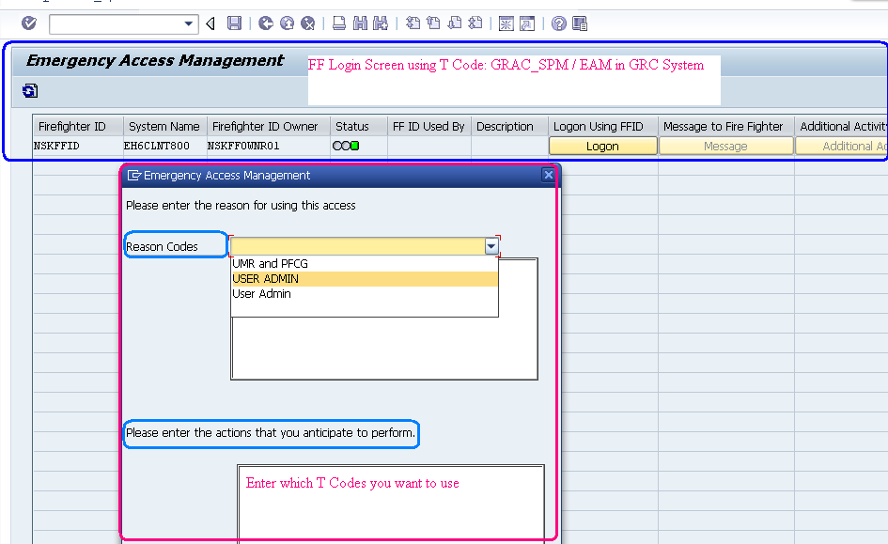

4. Technically wise types of Firefighter Applications?

- This is configured in IMG using parameter 4000 (Application Type).
- Only one application type can be configured at a given time.
- There are two types of Firefighter applications.
- ID Based FF
- Role Based FF

- ID Based Firefighter:

- The Firefighter ID created in the ECC System will be assigned to the user in the GRC system. Either manually or via an access request (NWBC).
- The Firefighter accesses their assigned Firefighter ID in the GRC server using the SAP GUI and transaction GRAC_SPM.
- The Firefighter ID for all remote systems assigned to the firefighter will be accessed from this transaction.

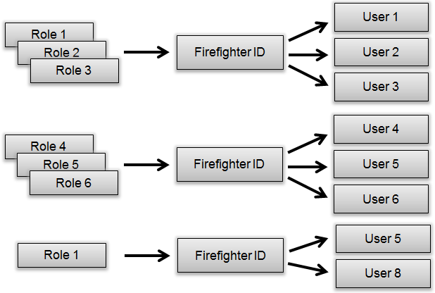

- Role Based Firefighter:

- The Firefighter roles created in the remote system will be assigned to the user in the GRC server.
- The Firefighter directly logs into the remote system using their user ID and performs activities which are provided in the user’s role and Firefighter role assigned to the user.
- The web interface facilitates the following:
- Firefighter ID/Role Owner Maintenance.
- Firefighter ID/Role Controller Maintenance.
- Reason Code Maintenance (system specific).
- Firefighter ID/Role assignment to Firefighter, Owner, Controller.

Note: Firefighter access is done centrally using the GRC server. Firefighters will log on to the GUI backend and execute transaction GRAC_SPM. Firefighter IDs for emergency access for all systems assigned to the user will display.
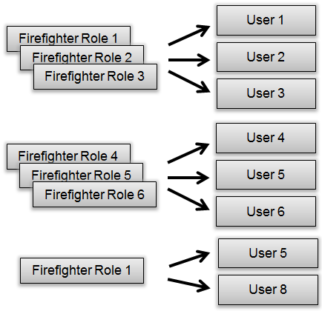

5. Usage of FF Concept or Difference b/w Centralized and Decentralized Firefighter? Or From End-user point of view and from GRC AC 10, SP10 FF activity usage types?
Access Control 10.0 provides a centralized logon pad for accessing the Firefighter IDs in all connected backend systems. There are 2 types of FFs.

- Centralized FF concept
- Decentralized FF concept

- Centralized FF Concept:

- When Firefighter activity is done by logging into GRC system, it is known as Centralized FF. Login into GRC and through GRC logon into ECC using RFC connection is called Centralized FF.
- Log onto the GRC system, and use transaction GRAC_EAM to remotely access all authorized plug-in systems. In this scenario, the GRC system and the EAM Launch pad provide a centralized access point to the plug-in systems for firefighting.

The centralized logon pad allows:

- Displaying all Firefighter ID assigned to the user.
- Logging in to all connected backend systems.
- Sending messages to other Firefighters who are using a specific Firefighter ID.
- Unlocking a Firefighter session not closed properly.

Centralized Firefighter steps summary:

- The Firefighter logons to central GRC system.
- T Code: GRAC_SPM, a screen will open up which will display all Firefighter IDs which are assigned to the current Firefighter in various systems.
- Click Logon to login into any of the systems assigned.
- Select a Reason Code.
- Enter a description.
- Enter a list of the actions to be performed.
- Click on Execute.

Note: The Firefighter can now do Firefighting activities on the connected backend system. When finished you need to close the session.
Centralized Firefighter Prerequisites:
- Application type is 1 for ID Based Firefighter.
- Set Parameter Group 6 super users management.
- Set Parameter ID 4000- Application type.
- Firefighter user must exist in the central access control system and the role SAP_GRAC_SPM_FIREFIGHTER.
While a Firefighter Session is running the status of the firefighter ID will display in red - reasons:
The Firefighter can take the following actions:
- Click Additional Activity to enter more information.
- If the firefighter ID is in use by another firefighter, choose Message to send notification to the other firefighter.
- Choose Unlock to unlock the Firefighter ID if it is locked.
Advantages:
- A FF can login into any plugin system from centralized GRC System.(Instead of user login into each plugin system)
- Since license cost increases planning to move to Decentralized.
Disadvantage:
- When GRC system is down for maintenance, all plugin systems are down and FF concept is not working.
- FF has to exist in GRC system. This increases license cost.

- Decentralized FF Concept:

- When firefighter activity is done from backend system, it is known as Decentralized FF concept.
- Firefighters can directly logon to the plug-in systems for firefighting; using the GRC system only for maintaining emergency access assignments and reporting.
- Log onto the respective plug-in systems, and use transaction /NGRCPI/GRIA_EAM to perform the firefighting activities.
- In this scenario, as firefighting is performed locally on each of the plug-in systems, you have uninterrupted firefighting access in case the GRC system is not available, however, you must make sure you have user accounts on each of the plug-in systems.
- Functions such as assignments, and reporting is still maintained in the GRC system.

6. Synchronization Jobs in GRC?

- The purpose of Synch jobs is to identify plug-in system data in GRC through NWBC.

SPRO------>IMG-----GRC----------> Access Control----------> Synchronization Jobs.

- Authorization Synch:

- Synchronizes PFCG Authorization data.
- Once in a month we run.

- Repository Object Synch:

- Synchronizes Profiles, Roles, and Users master data.
- Daily once we run.

- Action Usage Synch:

- Synchronizes action usage data (or)
- T Codes used by Users.

- Role Usage Synch:

- Synchronize role usage data (or)
- Roles used by users.

- Firefighter Log Synch:

- Synchronizes the firefighter logs from plug-in system to GRC system.
- This is used to synch to usage of FFID in ECC system.

- Firefighter Workflow Synch:

- This is used to send the FF log report to FF controller for review.

- Fetch IDM Schema:
- IDM- Identity Management
- This job is especially used for EP/ Java Systems only, not required for ABAP.

Note:
- SM37 ------ Checking Synch Job status.
- SLG1 ----- For Troubleshooting Synch Jobs.
- For ABAP systems the below 2 jobs have to be executed as soon as connector configuration done.
- Authorization Synch
- Repository Object Synch
- For JAVA system
- Repository Object Synch
- IDM Schema

7. If FFID Controller is on leave or not available? What you can do in this situation?

- In order to avoid this type of situation a single FFID Owner is not available then……..
- We maintain 2 FFID Owners for both Onshore (US) & Offshore (India). (Multiple Owner Strategy)
- Delegation of Ownership – Controls team can delegate the approval of FFID Owner from one person to another person.

8. If there is more than one FF accessing the system, how the controllers get FF Logs?

- Only one FFID can be used by FF one time.
- If the other user wants to use the FF at the same time it will be shown as a RED status and need to send a message to FF.

9. How do you pull FF Logs? (Or) How are you getting FF Logs?

- FF Log synch.
- Reports and Analytics Work center ----------- Consolidated Log Synch.
- From STAD pulls the data.

EAM Reports:
- Consolidated Log Report
- Invalid Super User Report
- FF Log summary Report
- Reason code & Activity Report
- SoD Conflict Report for FFIDs
10. Configuration Parameters – GRC system?

- IMG GRC Access ControlMaintain Configuration Settings
Parameter Group | Parameter ID | Parameter Value | Description
Workflow | 1113 | WF-BATCH | Access Control E-mail sender
EAM | 4000 | 1 | Application type
EAM | 4001 | 02 | Default Firefighter Validity Period (Days)
EAM | 4002 | YES | Send Email Immediately
EAM | 4003 | YES | Retrieve Change log
EAM | 4004 | YES | Retrieve system log
EAM | 4005 | YES | Retrieve Audit log
EAM | 4006 | YES | Retrieve OS command log
EAM | 4007 | YES | Send log report execution notification immediately
EAM | 4008 | YES | Send Firefighter ID login notification
EAM | 4009 | YES | Log report execution notification
EAM | 4010 | SAP_GRC_SPM_ FFID | Firefighter ID role name
EAM | 4015 | YES | Enabling Decentralized FF

Access Risk Analysis (ARA)

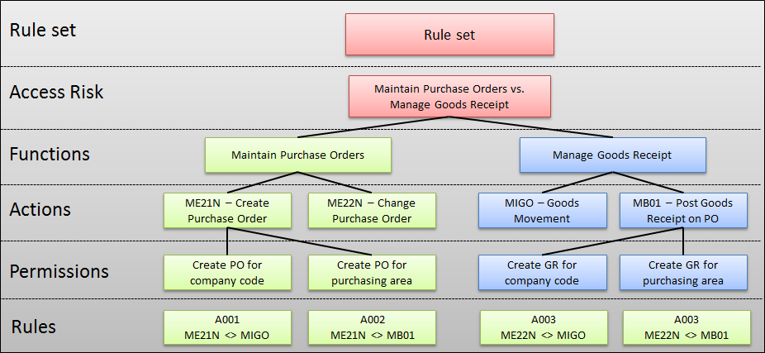

11. Why Access Risk Analysis?

- Access risk means one / more actions or permissions that are available to a single user/ single role/ profile/ HR Object that leads to fraud or unintentional errors. To avoid this type of miss use of authorizations SAP introduces SAP GRC ARA.
- The Access Risk Analysis tool is the backbone of SAP GRC Access Control. This is used to detect, remove, and prevent access and authorization risks means reporting SoD violations before they occur.

ARA performs following activities:

- Identifying the Risk and notifying the access and authorization-related IT tasks.
- Risk Remediation means when the risk identified we are going to remove the access of T Codes and Authorizations if they are conflicting.
- Risk Mitigation means when the risk identified and can’t be removed access due to job nature or for some other reason and we are going to monitor their activities.
12. What is Risk?
- Risk means one or more T Codes or Authorization Objects are available to a single user is called as Risk. Risk means potential threat which needs to be managed in order to avoid potential losses to the organization.
- Example: SCC4 + SE09 or SCC4: S_TABU_DIS+ SE09: S_TRANSPORT.

13. Types of Risk?
In SAP GRC there are 3 types of risks.
- SoD Risk (SoD Risk at Action Level and Permission Level )
- Critical Action Risk
- Critical Permission Risk

- SoD Risk:

- SoD means one person having the ability to perform two or more conflicting functions to control a whole process from beginning to end without the involvement of others.
- When a user having access to two or more Conflicting Functions that is called as SoD Risk.

- Example: One person might be able
- Maintain Purchase Order (ME21N, ME22N) Vs. Manage Goods Receipt (MIGO – Goods Movement, MB01 – Post GR PO) or
- Transport Administration (TMS, STMS, SE09) Vs. Role Administration (PFCG). Here risk is the person fraudulently create role and move transport across the landscape.

- Even within SoD risk, risk can be of two types.

- SoD Risk at Action level:

- Combination of two or more conflicting T Codes is called as SoD Risk at Action level.

- SoD Risk at Permission level:

- Combination of two or more conflicting Authorization Objects and Authorization values is called as SoD Risk at Permission level.

Note: In order to avoid false positives we need to run risk analysis at Permission level also.

- Critical Action Risk:

- When a user is having the access to a Critical T Codes, which alone can damage the SAP system it is called as Critical Action Risk.

Example:

- SPRO/SCC5/ SCC4/STMS etc……..
- In production system having change or generate access of PFCG is a critical action risk.
- Having change access to tables under SE16 T Code.

- Some T Codes are so critical in nature, who has access needs to be identified and assigned to ensure that access is appropriate.
- This is different from SoD risks in this the person only needs to have access to a single function.

- Critical Permission Risk:

- Like a critical action, there is some Critical permission (Authorization Objects) that is considered critical on their own.

Example:
- Having background job administration permissions might be considered critical by certain organizations.
- S_DEVLOP (01, 02) / S_TABU_DIS or NAM (01, 02, 06-Delete) / S_PROGRAM (01, 02, 05- Execute).

- Risk levels are 4 types:
  - Low
  - Medium
  - High
  - Critical
Note: Always Permission level report (1023) value= 02 gives accurate results. We are not going to create Risk ID with Single Function.

14. What is Global Rule set, Business Process and Sub Process? Risk ID? Function ID?
A. Global Rule Set:
- Rule set is a combination of risks and generated rules, using which we do risk analysis of plug in system for different types of risks. Rules generated from the Risk are called as Rule set.
- Why Rule Set: To create Risk Ids, generate rules from risk ids and for running risk analysis Rule set is required.
- Identifying any combination of these conflicting actions and permissions from user profiles is more difficulty to handle manually.
- To simplify this activity Access Risk Analysis Rule Set is created by grouping of Transactions and Functions. Conflict between two functions is called as SoD.
- There are 154 risks identified and delivered in SAP GRC system as part of the Global Rule Set.
- T Code: SCPR20 and BC Set: GRAC_RA_RULESET_COMMON and then activate it. This populates the Business Process, Sub-Process, Functions and Rule Set.
SPRO --- IME --- GRC --- AC --- Maintain Business Process and Sub Process.
Business Configuration Sets: Activation
BC Set | GRAC_RA_RULESET_COMMON
Short Text | Rule set for Common Rules

- Rule Set is used for determining the group of access risks that are used when running an ARA. Several Rules are combined together in a Rule set. The Rules are available as Rule IDs in a separate table called GRAC ACT RULE (SoD Action Rule Details).
B. Business Process:
- BP includes categorization of our business functions. Ex: Finance, MM, CRM, HR.

C. Sub process:
- Even within business process we can define sub process. This sub process is used for Mitigation control and maintenance.
- Ex: In my organization they define IT has BP and sub processes like BASIS, Security, and DBA. Finance BP ------> AP, AR, GL, Asset Management.
- Both Functions and sub process are a sub classification of Business process. Whereas Functions are used for defining a risk and Sub process is used for Mitigation control and maintenance.

D. Risk ID:
- Risk IDs are combination of two or more conflicting functions. Each function is grouped with Actions and permissions. Actions are T Codes of SAP ERP system and Permissions are Authorization Objects.

E. Function IDs:
- Function IDs are group of Actions and permissions. Functions are a sub classification of Business process and used for defining a risk.
- Ex: Under BASIS BP we have functions like Client & Transport Administration.

15. Rule Set types and How to create Customized Rule Set?
Rule set is a combination of risks and generated rules using which we do risk analysis of plug in system for different types of risks.
There are two types of Rule Sets.
- Global Rule Set (GRS)
- Customized Rule Set
a. Global Rule Set:
- Activate BC sets below
GRAC_RA_RULESET_COMMON
GRAC_RA_RULESET_SAP_R3

Once these BC Sets are activated, it will create a Globalized Rule set delivered by SAP.

- Generate SoD rules for the uploaded Rule set:
SPRO -----------> IMG ---------> GRC ------------> AC --------> ARA --------> SoD Rules --------------> Generate SoD Rules.
- After generation of SoD rules our Global Rule Set becomes active and can be used for risk analysis.
- However in real time people don't use GRS. Clients preferred to use CRS.

b. Customized Rule Set:
- Creating a copy of GRS into our own name space.
- Discuss with the business teams or Control teams or Internal Audit teams relating to "types of risks" you want to include in your customized rule set.

Activities:
- Creating a new SoD Risk.
- Creating a new Critical Action Risk or Critical Permission Risk.
- Activating or Inactivating a Risk.
- Increasing or Decreasing the Risk levels (High, Low).
- Creating risks for Customized T Codes and Authorization objects.

- Ex: According to SAP GRS having Functions - Client admin and Transport admin is a High/Medium level SoD risk. Where as in real time companies can't afford to have separate BASIS teams for Client admin and Transport Administration. So we will discuss with Control/business teams to make it has Low level/ De activate.

Prerequisites: Run the Authorization synch Job and Repository Object synch Jobs.

16. Risk analysis and types of Risk Analysis?
- Risk means potential threat which needs to be managed in order to avoid potential losses to the organization. Risk means two or more T Codes and Authorization Objects are available to a single user is called as Risk.

- This risk can be analysis in 2 ways.
1. User Level Risk Analysis: We analysis only Roles at user level.
2. Role Level Risk Analysis: We analysis T Codes (Action).

- Risk Analysis: NWBC----- Access Management ------ ARA ------ User Level.

17. Risk life cycle or when we use RS, RR, and RM?
Risk Life cycle:
Defining Risk
↓
Risk Identification
(User & Role Level)
↓
Remove Risk (R Remediation)
↓
Reduce Risk (R Mitigation)
↓
Continues Compliance (Simulation)

18. Risk Simulation?
- Simulation or what if mode was used during Continues compliance/ support phase whenever changes to be made we are expect to run risk analysis in Simulation mode in GRC Development / Quality system connected to my Plug in Development system.
- Simulation or what if mode means where risk analysis is done before actual roles or users gets created/ modified.
- Risk simulation, means Role assigned to a user or T Codes added/removed from a role and sees the possible changes will make on the risk analysis.
- Ex: A new user needs to be created a set of roles. (or) Existing user may request for a new role.

Risk Simulation can be done in 2 cases / RS requirements:

- User Modification (Role assigned to a user).
- Role Modification (Adding/removing T Codes + A.Os from a role).

How/ when do you use Simulation?

- If the project has only ARA and EAM components we will do risk analysis manually.
- If we are using ARM also my risk analysis stage is configure to run risk analysis in Simulation mode using ARM.

Types of Risk Simulation:

- User Level Simulation:

- We simulate only Roles in user level.
- Ex: Role1+Role2= No Risk + Role3= before assigning Role3 to a user we are doing Risk Simulation.
- Exclude values: Simulation in Removal of access.
- Risk from Simulation only: To check the new risk is coming due to simulation only.

- Role Level Simulation:

- We simulate only at Action level (T Codes).
- Ex: Role1 = T1+T2+T3+T4 now adding T5 to same role. This is Risk Simulation at role level.
How does simulation get its role data?
- Repository Object synch which pulls data of Users, Roles and Profiles.
- Using Role Import we need to import all technical roles from plug in system into BRM Repository.

19. Risk Remediation?

- Removal of risk is called as RR. RR is an activity which is run after doing risk analysis; it aims to cleanup roles in plug in system.
- Removing the T Codes from the role which are conflicting in nature and ensuring role is SoD free.
- It is a time consuming part, as you need to check each and every role for risk analysis.

Activities in RR:

- Remove unused roles in plug in system. (AGR_USERS, SUIM - we find unused roles).
- Remove repetitive roles- roles having a common T Code.
- Check your role design- always assign composite role based on job function of the user.
- Remove extra access/ roles assigned to users and try to provide this extra access through FFIDs.

There are 3 ways to start the cleaning process:

- Removal of Role to User.
- Removal of T Codes from the role.
- Mitigate the risk using mitigation control assignment against the user and monitor on a regular basis.

Note: The first option is selected on daily basis, whenever user has a risk at user level. Second option is selected when there is a risk at role level or the same risk is repeated for multiple users.

20. Risk Mitigation?
- Even though there are SoD conflicts, which cannot be removed from the role and allows the users to access them. These T Codes might be necessary for that particular role to execute that task and assign Mitigation Controllers to monitor user activities.
- Here t-codes will be retained in the role itself and monitor user activities using GRC system through Mitigation Controls.
- Security team creates Mitigation Controllers in GRC system and internal control team is responsible for assigning Mitigation Controllers to Risk IDs.

Required attributes for RM:
- Mitigation Controllers (Owners and Monitors).
- Organizational Hierarchy.
- Risk IDs.

How to create Mitigation Control IDs:

- Create Mitigation Controllers (Owners and Monitors) with required roles using SU01 in GRC System.
- Add Mitigation Owner and Controller in Owners table using NWBC --------> Setup ----> Access Owners ----------> Access Control Owners.
- Create Root organization Hierarchy using SPRO --------> IMG -------> GRC ---------> Shared Master Data settings -----------> Create Root organization Hierarchy.
- Define owners for the Root Organization Hierarchy using NWBC --------> Setup -------> Organizations ---------> Organizations.
- Assign Mitigation Control IDs to Risk IDs and others using NWBC ---------> Setup ----> Mitigation Controls --------> Mitigation Controls.
- Once a set of Mitigation Control IDs are created during implementation phase then at SoD Control stage my internal control teams will take care of assigning Mitigation Control IDs to users/ requestor.

21. Online Risk Analysis and Offline Risk Analysis?
- Before run offline risk analysis must be configure Parameter 1027 “Enable Offline Risk Analysis” to YES.
- Offline risk analysis is not real-time data, but it is dependent on the last date of the running Batch Risk Analysis. The Batch Risk Analysis is run as background job in GRC by using
T Code: GRAC_BATCH_RA
Program: GRAC_BATCH_RISK_ANALYSIS.
- The benefit of using offline risk analysis is it responds in time.
- The system uses Offline Risk Analysis data to update and generate UAR review workflow requests.
- This is the same batch risk analysis that is run to update the management reports and companies should be running this on a frequent basis to ensure their management reports are accurate. Running the Offline analysis is the same as drilling down via the Management View.
- Ex: Whenever we are running risk analysis, we have the option to change ignored locked users field other than what is set up in the configuration. However, if you change this to NOT ignore locked users and run RA in Offline mode, you will not receive any conflicts. Because no locked users were evaluated during the batch risk analysis. Running this report in online mode may turn up conflicts with locked users.
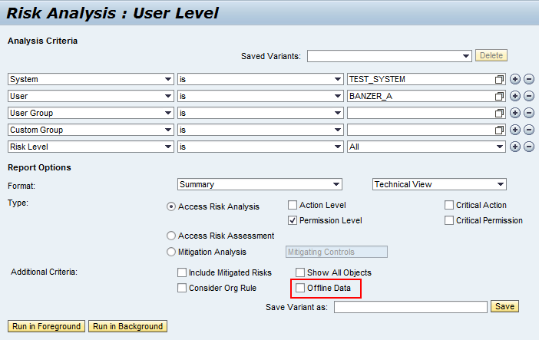

22. Types of Users in ARA?

GRC System --------TCODE: SU01

Risk Owner Mitigation Controller/ Approver Mitigation Monitor
SHIVARO | KRISHMITCO | MITMONITOR
Dialog | Dialog | Dialog
SAP_GRAC_RISK_OWNER  SAP_GRC_FN_BASE  SAP_GRC_FN_BUSINESS_USER  SAP_GRC_NWBC | SAP_GRAC_CONTROL_OWNER  SAP_GRAC_CONTROL_APPROVER  SAP_GRC_FN_BASE  SAP_GRC_FN_BUSINESS_USER  SAP_GRC_NWBC | SAP_GRAC_CONTROL_MONITOR  SAP_GRC_FN_BASE  SAP_GRC_FN_BUSINESS_USER  SAP_GRC_NWBC

Net Weaver Business Client

NwbcSetup Work center Access Owners Access Control Owners
- Create Button
Group Type
- Owner
- Owner Group
- LDAP Group
Owner: SHIVARO
Type | Description | Select
Risk Owner

Click SAVE
Click Close

- Create Button
Group Type
- Owner
- Owner Group
- LDAP Group
Owner: KRISHMITCO
Type | Description | Select
Mitigation Approvers

Click SAVE
Click Close

- Create Button
Group Type
- Owner
- Owner Group
Owner: MITMONITOR
Type | Description | Select
Mitigation Monitors

Click SAVE
Click Close

It’s mandatory to configure the Access Control Owners (Risk Owner, Mitigation Controller/Approver, and Mitigation Monitor) in Organization.
- NWBCSetupOrganizations
- Organization Hierarchy Root Org Unit Open
Owners TAB
AC Owners and Add Row
Name | Type | User ID
SHIVA RISK OWNER | Owner | SHIVARO
KRISHNA MITIGATION CONTROLLER | Owner | KRISHMITCO
MITIGATION MONITOR | Owner | MITMONITOR
Click on save button.
Mitigation Controller/Approvers:
MAs are assigned to control and they are responsible for approving changes to the control definition and assignment when workflow is enabling.
Mitigation Monitor:
MMs are assigned to control to monitor activity and may receive control monitor alerts.

23. Risk Terminator?
The plug-in system is configured to connect with Access Risk Analysis and stop any further processing if you have risk during one of the following four scenarios:
- When transactions are added to a role and it’s generated using T Code: PFCG.
- When users are assigned to a role using T Code: PFCG.
- When a role/profile is assigned to a user using T Code: SU01
- When a role/profile is assigned to a user using T Code: SU10.
24. Maintaining SAP Access Control ARA Configuration Parameters and checks?
SPRO IMG GRC Access Control Maintain Configuration Settings
Parameter Group | Parameter ID | Value | Description
Mitigation | 1011 | 365 | Default expiration time for M Control Assignment
Mitigation | 1012 | NO | Consider Rule ID also for mitigation assignment
Mitigation | 1013 | NO | Consider System for mitigation assignment
Risk Analysis | 1021 | No | Consider organization rules for other applications
Risk Analysis | 1022 | T90CLNT090
Risk Analysis | 1023 | 2 | Default report type for risk analysis
Risk Analysis | 1024 | 3 | Default risk level for risk analysis
Risk Analysis | 1025 | Global | Default rule set for risk analysis
Risk Analysis | 1026 | A | Default user type for risk analysis
Risk Analysis | 1027 | YES | Enable Offline Risk Analysis
Risk Analysis | 1028 | No | Include expired users
Risk Analysis | 1029 | No | Include locked users
Risk Analysis | 1030 | YES | Include mitigated users
Risk Analysis | 1031 | YES | Ignore critical roles and profiles
Risk Analysis | 1032 | YES | Include reference user when doing user analysis
Risk Analysis | 1033 | YES | Include role/profile mitigating controls in risk analysis
Risk Analysis | 1034 | 100 | Maximum number of objects in a package for parallel processing.
Risk Analysis | 1035 | YES
Risk Analysis | 1036 | NO
Risk Analysis | 1037 | YES
Workflow | 1061 | NO | Mitigating Control Maintenance
Workflow | 1062 | NO | Mitigation Assignment
Workflow | 1063 | NO | Risk Maintenance
Workflow | 1064 | NO | Function Maintenance
ARA Configuration checks:
- Check RFC to the concern plug in system.
- Check connector configuration checks like "Assigning Integration Scenarios to Connectors".
- BC sets activation.
GRAC_RA_RULESET_COMMON
GRAC_RA_RULESET_SAP_R3
Once these BC Sets are activated it will create a Globalized Rule set delivered by SAP.
- People generally don't use Global Rule Set directly delivered by SAP. Instead they modify the GRS and copy into their own names space.
- Check parameters related to ARA.
- Run synchronization jobs like Authorization Synch and Repository Object Synch.

25. Batch Risk Analysis? Why it is used?
- The risk analysis can be performed against single users or multiple users; similarly Batch Risk Analysis also applies to single or multiple roles or profiles from SAP NWBC.
- Performing the risk analysis across the entire system for users and roles is called as Batch Risk Analysis.
- SAP GUI GRC System
TCODE: GRAC_BATCH_RA
Job Name: RISK ANALYSIS BATCH MODE_25MAY
System: T90CLNT090
Batch Processing Mode: Full
Rule set: GLOBAL

Object Selection:
- User Analysis
User: *
User Group: *
- Role Analysis
Role: *
- Technical Role
- Profile Analysis
Profile: *
Risk Analysis Type
- Action Level
- Permission / Critical Action / Critical Permission Level
- Critical Role / Profile Level
Click Execute Button
You will get result, your background job scheduled successfully.
Now, you can monitor the background JOB with TCODE: GRACRABATCH_MONITOR
After completion of this background job, you should be able to view various reports from Access Risk Analysis reporting dashboard.

26. Risk Analysis Reports?
NWBC ------------> Reports and Analytics ----------> ARA Reports
  - Access Rule Summary
  - Access Rule Detail
  - Mitigation Control Report
  - Mitigation Object Report
  - User Risk Violation Report
  - Role Risk Violation Report
  - Profile Risk Violation Report

Access Request Management (ARM)
VIRSA 4.0 ----------- Access Enforcer
GRC AC 5.3 --------- Compliant User Provisioning (CUP)
GRC AC 10.1 ------- Access Request Management (ARM)
Compliant: Following or obeying the rules and regulations (SOX Law).

Purpose of using ARM:
- Automate Approvals through Workflow.
- Auto provisioning – Automate User Maintenance.
Advantages of Automation:
- No time delays in user maintenance.
- Reduction of errors.
- Enforce that process can be followed.
User Administration:
- User Creation
- User Modification
- User Deletion.
Process to be followed for User Administration:
- User has to fill the SAP Access form.
- It has to be approved by his Reporting Manager.
- It has to be approved by Role Owner (for the roles user is requesting).
- Security team will create or modify or delete the user as per request.
How can you ensure that above process is not violated?

27. Why Access Request Management?
- ARM is used for automated user administration process and other things.
- Access Request Management (ARM) is the provisioning tool that will provide the company with the ability to manage SAP user access management and Role assignment within connected system.
- Provisioning access to users involves the user completing the forms that request access to backend system.
- Access request is created in GRC by requestors and submitted for approval. The requestor would be responsible for selecting required by the user. Once submitted the request is routed online by workflow to relevant approvers.
- User Access Management automates the access provisioning approval process and provisioning appropriate roles and permissions via workflow to the respective requested plug-in systems.
- When a user (requestor) requests resources (roles or access privileges) for which the user doesn’t have permissions using User Access Management.
It automatically forwards the access request to designated managers and approvers via workflow.
At the end of approval process, roles and permissions are automatically applied to the respective systems with requested privileges when the access requests are approved. During this process User Access Management checks for Segregation of Duties (SoD) and Critical Access Analysis for the user by combining the user’s existing privileges with those requested using the integrated Access Risk Analysis tool.

In our project 4 stages are there:
Whenever a Requestor submit a request (New or Change request), the request goes through 4 different stages for approvals.
a. Manager
b. Role Owner
c. Risk Analysis Stage (Detour Path)
d. Security Stage

Detour Path - Explain?

- Whenever a request at Risk analysis stage is found with risk the request now its take a Detour path to internal controls team to assign Mitigation Controllers.
- At user level we assign Mitigation Controllers.

Notes:

- We have made configuration for ARM request if one role is rejected at any level whole request it gets rejected.
- User needs to submit the request again.

Escalation Path:

- Whenever approver fails to approve especially role owner after 5 days, the request will get alternative approver (every BR will have 2 approvals i.e. Primary & Alternative).
- Security team making sure that roles are provisioning to user correctly to check the logs SLG1 in GRC System.
- We have a problem for removal of groups in portal in remove request. In that case we need to check SLG1 logs for errors.
- Sometimes whenever Manager is on Out Of Office (OOO), security team is asked to forward the request to "Managers Manager" . (Go to search request -----> Enter the request no. -------> Click on Administrator --------> Click on Action type Forward and to give Managers Manager USER ID).
- To find the status of request at which stage it is pending ---------> Go to search request ------------> Click on Incident status.
- If somebody raises a wrong request, will cancel the request at Cancel Incident.
- For JAVA systems providing FF access we will manually assign FF Role to users (Technical Team) based on Incident.
- We are not using FFID concept directly in JAVA systems.

28. Different User Roles in User Access Management?
The available roles for user access management are:
- General Users
- Requestors
- Approvers
- Administrators
- Auditors

- General Users:

- For some customers the situation demands some or all of the new users not to have any other authorization, but still they need to create their user requests to have proper IT access to perform their duties.
- This can be performed by the user if the user can access a generic URL.

- SAP_GRC_FN_BASE
SAP_GRC_FN_BUSINESS_USER

- These are basic roles, required to log on to the SAP Access Control system to create a new request or change a request.

- Requestors:

- Sometimes this role is confused with general users. The simple variations is that a requestor is the person who creates a request on behalf of others, whereas a general user is the terminology used to represent the person whose user ID is in the access request.
- Requestors should have privileges to access the SAP GRC system, and the roles are the same as mentioned previously for general users.

- Approvers:

- In SAP Access Control there are different types of users in the system, such as firefighter ID, firefighter users, owners, controllers, and so on.
- Various Approvers in the SAP Access Control System are role content owners, role assignment owners, function approvers, control owners, mitigation owners, and various access approvers that will be maintained in various stages in the MSMP workflow.

- Administrators:

- SAP GRC System administrators are privileged to configure, maintain master data or change master data, and troubleshoot some issues in the system.
- This type of user has all of the privileges of the SAP Access Control system. While providing wide access to the system, make sure that all changes carried out by anyone who has privilege to change master data in SAP Access Control are captured in the change log of the system to monitor and audit them later.

- Auditors:

- Auditors are those who verify whether IT or system access are provided correctly, and they are in place to meet the governance and compliance enforced in the company to avoid any access risks.
- These users will get only the reporting authorization to execute various reports in the SAP Access Control System.

29. Configuration Parameters in GRC ARM?
You only need to configure User Access Management related configuration parameter groups such as Workflow, LDAP, Role selection, and Role mapping.
Param Group | Param ID | Parameter… | Description
Risk Analysis – Access Request | 1071 | NO | Enable risk analysis on for submission
Risk Analysis – Access Request | 1072 | NO | Mitigation of critical risk required before approving the request
Access Request Role Selection | 2031 | YES | Allow all roles for approver
Access Request Role Selection | 2032 | A | Approver role restriction attribute
Access Request Role Selection | 2033 | YES | Allow all roles for requestor
Access Request Role Selection | 2034 | A | Requestor role restriction attribute
Access Request Role Selection | 2035 | YES | Allow role comments
Access Request Role Selection | 2036 | No | Role comments mandatory
Access Request Role Selection | 2037 | YES | Display expired roles for existing roles
Access Request Role Selection | 2038 | YES | Auto approve roles without approvers
Access Request Default Roles | 2009 | NO | Consider default roles
Access Request Default Roles | 2011 | REQUST | Default Role Level
Access Request Role Mapping | 2014 | NO | Enable Role Mapping
Access Request Role Mapping | 2015 | NO | Applicable to Role Removal

30. Configure the MSMP Workflow?
- The Multi-stage Multi-path (MSMP) workflow is the key engine that moves the request from one stage to the next stage within the ABAP workflow engine.
- SPROGRC Access Control Workflow for Access Control Maintain MSMP workflows.
- Alternatively, you can execute T Code: GRFNMW_CONFIGURE_WD to open the MSMP application setup in a browser window.
MSMP Steps:
- Process Global Settings
- Maintain Rules
- Maintain Agents
- Variables & Templates
- Maintain Paths

- Process Global Settings:

- Select SAP_GRAC_ACCESS_REQUEST.
- Click on Display/Change button.
- Click Add or Modify button from the Notification Settings area.
- This global setting is required for the first two workflow processes only, and the rest may not require this Notification Settings because they send notification to pass information to the user or requestor about access request upon submission of the request, at the start of the workflow, and completion of request at the end of workflow.
Notification Event | Template ID | Recipient ID
END_OF_REQUEST | GRAC_AR_CLOSE | GRAC_USER
REQUEST_SUBMISSION | GRAC_AR_SUBMIT | GRAC_REQUESTER

- Maintain Rules:

- These are the default rules for different rule types such as agent rules, initiator rules, notification rules, and so on.
- You need to maintain the global rules for the initiator and for notification; you can have one initiator per process.
// accept default settings here…
Process Initiator: GRAC_AR_INITIATOR
Notification Rule: GRAC_NOTIF_VAR_RULE_AR
- Maintain Agents:

- It’s a more generic setting, and those who are approvers are actually defined in every stage and maintained in step 5 – Maintain Paths.

- Variables & Templates:

- It is used in notifications to various uses of User Access Management.
- The two steps – Maintain Agents (step 3) and Variables & Templates (step 4) – can be used with default SAP – provided values.

- Maintain Paths:

- For the MSMP workflow configuration, you maintain the workflow path and define various stages.
Path ID | Path description
DELETE_PATH | DELETE PATH
DETOUR_PATH | DETOUR PATH
GRAC_DEFAULT_PATH | Default Path
NEW_USER_PATH | New User Path

- Approvers or agents are assigned to these stages with the functions or tasks that need to be performed at every stage. You also define here what type of notification is sent to whom.

MSMP

TCODE: GRFNMW_CONFIGURE_WD (or)
T Code: SPROGRC Access Control Workflows for Access ControlMaintain MSMP Workflows.
- MSMP is the new workflow engine used within SAP Access Controls 10.0 and is capable of directing requests down multiple approver routes simultaneously.
- It’s used for the management of automated approval workflows in User Access Management but can also be triggered for the other SAP Access Control modules, including Access Risk Analysis master data updates or role building approval workflows.
- The big change is that it works off of a multitude of different rules to govern what should happen to the requests. All of these rules to be defined up front before they can be assigned in the configuration and used in the workflow processes.
- Based on the GRC_MSMP_CONFIGURATION BC Set activation, there are eight different processes and process ID’s such as Access Requests, Function or Risk Maintenance, User Access Review, SoD review and Firefighter Log Review and so on. Components of all these processes are populated with MSMP related core values in these various steps to carry out configuration.

- Configure Process Global Setting
- Maintain Rules and Rule Results
- Maintain Agents
- Variables and Templates
- Maintain Paths and Assign Stages to Path
- Maintain Route Mapping.
- Generate version.

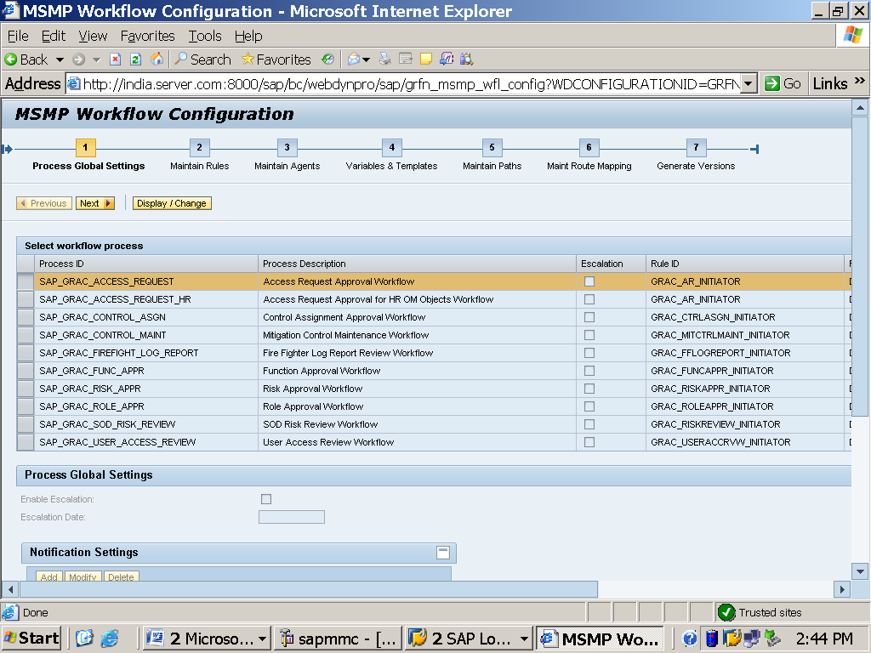

- Configure Process and Global Setting:

- Upon invoking MSMP workflow, MSMP workflow initial screen shows seven steps with the first process SAP_GRAC_ACCESS_REQUEST highlighted.
- Process ID’s are pre-delivered as part of the MSMP BC Set GRC_MSMP_CONFIGURATION activation.
- These processes basically cover a specific scenario and the process description for each process ID is self-explanatory for scenarios.
You can start editing the entire MSMP process by clicking the Display/Change button.

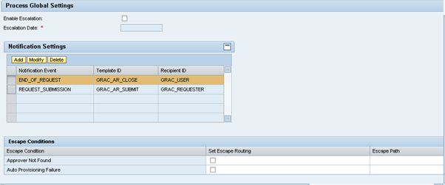

Process Global Settings there are two variables for you to set.

- This setting applies to each and every stage/path uniformly.
- In this stage we don't have to check Enable Escalation.
- Escalation in terms of Days.
- If an approver fails to approve an request, Escalation happens in two ways.

a. Escalation Notification sent to the Approver.
b. Escalated to the Alternative Approver.

1. Enable Escalation:
- It enables global escalation on any workflow that was pending for approval and the deadline monitoring for the fixed date. After this date all work items escalate for this process.
2. Escalation Date:
- This is the date on which all work items for this process are escalated.

Notification settings the variables you should set are:

1. Notification Event:

- It means you are configuring a predefine Notification/Mail that will trigger based on an event.
- In this case every Process ID needs to be configure with a Notification Event.
- Notification Event is beginning of event with REQUEST_SUBMITION and ending of event with END_OF_REQUEST. (SAP Standard Notifications).

2. Template ID:

- The template is maintained for the message that has to be sent either at REQUEST_SUBMITION or at the END_OF_REQUEST processing notifying the requestor or user of the outcome as message what is the request number that had been created with details or approval information after the end of the workflow process.

3. Recipient ID:

- This is the recipient of the end of request notification message (configured as an agent) which can be user or requestor.
- Self + Request = User
- Other + Request # User.

Escape Conditions the variables you should set are:

- Escape Conditions:

- This table has two entries, one each for two escape conditions: a. Approver Not Found
b. Auto Provisioning Failure.

- Set Escape Routing:

- This checkbox need to be set to activate the respective escape paths.

- Escape Path:

- Path the request follows if no agents are found for any stage or failure during auto-provisioning. This is set in Step 5 and is required when Escape Routing is enabled.
- To maintain the escape path, it should be created in Step 5 to set the stage for the above mentioned escape path to which the request should follow.

- Escape Stage:

- This escape stage number dictates at which approval stage this escape routing should be triggered in case of if any escape condition arises.

2. Maintain Rules and Rule Results:

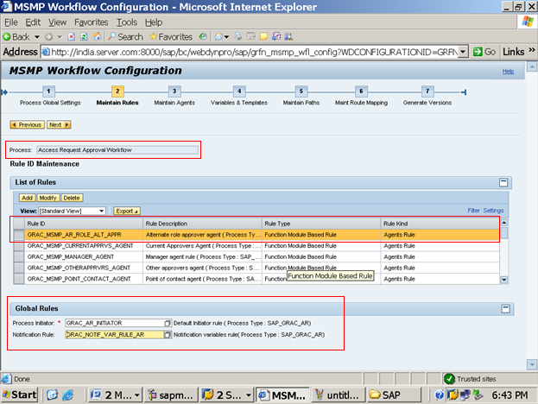

- The purpose of Rules and Rule Results is to identify agents in the workflow and condition based determination of different workflow paths.
- Rules are decisions that are associated with rule results.
- MSMP Workflow engine makes use of rules and their rule results to take decisions like.... a. In case of New Request, the request has to take which path.
b. Within a stage who should be the Approver.
- Four different rule types are available to maintain in the system:
1. ABAP Class Based Rule
2. BRF Plus Rule
3. BRF Plus Flat Rule (Line item by Line item)
4. Function Module Based Rule
- These rules are used to find the correct Path, Agents or Routing to a different path based on logic designed in the rules.

Example: If the user request to a role in System A, then workflow should go to Path_1; if the system is different, then workflow should route to Path_2.

- Under RULE ID MAINTENANCE table a list of rules is provided by default, which can be modified or new rules can be added as needed.

1. Rule ID:
- The unique name for the rule to identify different rule types and rule kinds that are used in the MSMP workflow process.
2. Rule Description:
- Meaningful description to the purpose of the rule.
3. Rule Type:
- There are four rule types based on the underlying technology that helps to make decisions.

4. Rule Kind:

- Four different rule kinds are used during the execution of the MSMP workflow process to determine results for initiator, agents, routing, and notification variables.

- Agent Rule
- Initiator Rule
- Routing Rule
- Notification Variable Rule

A. Agent rule:

- Agents are approvers that need to approve a request at a particular stage in order to make the request proceed to next stage.
Ex: Manager, Security, Role Owner.
- You can create multiple rule IDs for the agents rule kind based on your definition of multiple agents such as Role Owner, Risk Owner or any other custom agent.

b. initiator rule:

- This rule is used to direct the workflow path based on the rule, result which is defined by the rule type.
- This rule determines the path which a request needs to take when a request is successfully submitted.

Ex: a. Request Type (New User) it should take Path 1.
b. Request Type (Delete User) it should take Path 2.

- Only one initiator rule per process can be defined.
- In SAP Access Control 10.x, rather than specifying an initiator for each workflow path, you now only have one that contains all of the different possible variations that can be achieved by rule result values.
- SAP provides one Standard Initiator Rule/ Default Initiator Rule. i.e. ......... GRAC_AR_INITIATOR with only one default rule result. This is FMBR.
- We need to do customization i.e. Create Initiator Rule by using BRF Plus Flat Rules.
Ex 1: Using BRF Plus Flat Rule we can define any of the Rule kind.
Ex 2: Using ABAP Based Rule we can create any of the Rule Kind.

C. Routing Rule:

- You can use this rule to route a request from one path to another based on the rule result.
- These rule determines route which a request should take if a condition it meet.
Ex: When the request faces SoD Violation the request should be routed to another path (Detour) to controls team to assign Mitigation Controls to User IDs.
- Most of the times we make use of SAP Standard FMBR Routing rules in our MSMP Workflow.

D. Notification Variables Rule:

- This is also defined once per process in global settings. This rule helps to send notifications to various agents.

Rule Results:
- The rule result value can be a single or multiple results, which is used in workflow paths or stages to determine either agents or paths depending on the rule kind.
Trigger Value Description:
- Rule results require meaningful description, which you maintain here.
Process Initiator:
- There can be only one active initiator per process. This initiator needs to cover all paths defined for the process that are to participate in the process.
Notification Rule:
- Rule to determine notification variables used in notification templates.

- BRF Plus Rule:

- Rule defined in the BRF+ application to get rule results depending on conditions inside the rule

- Function Module Based Rule:

- Function module coded to output the rule results.

- ABAP Class Based Rule:

- Class method coded to output rule results.

- BRF Plus Flat Rule (Line-Item by Line-Item):

- BRF+ rule defined for only one line item. (This rule is called once for each line item in the request).

3. Maintain Agents
- After configuring rules and rule results, we have to define various agents like Access Request Approvers, Role Owners and Notification agents (requestors and end users involved in workflow process).

- Agent ID: Define the logical approver ID, which is a required field.
- Agent Name: Give a description of the logical approver ID.
- Agent Purpose: Agents are defined in the MSMP workflow for either approval purposes or to notify about the activities.

Approval: This agent will get work item from workflow for approval purpose.
Notification: Agents in the system for notification purpose to convey the information about the workflow.
Agent Type: -Define dynamic approvers that can be assigned to any workflow stage.
- Directly Mapped Users:
This configuration is used for defining static user groups used within workflow process.

- PFCG Roles:
PFCG roles assigned to a user as agent and workflow determines the agent based on the role assignment.

- PFCG User Groups:
PFCG groups assigned to a user; for example this can be specific process owners that are define in a user group.

- GRC API Rules7:
This is used to fetch rule-based approvers such as manager, role owners, risk owners, and so on via associated function modules. This field is mandatory if Agent Type is defined as Function Module Based Rule in an earlier step.
For ex: - manager approval stage with GRAC_MSMP_MANAGER_AGENT

4. Variables and Templates
- These templates are used to send email messages to the approvers/notification receivers that contain some fixed texts and variables, such as user ID, user name, request type, role or provisioning details, system name, to give the message to the receiver of this workflow content for decision making on approval or rejection.
- All of this customization can be done to these templates and variables using TCODE: SE61
- Notification Templates
- Template ID
- Message Class
- Message Number
- Notification Variables
- Temp. Variable
- Variable Description

- Maintain Paths and Assign Stages to Path

- Every workflow path contains one or more intermediate nodes for the decision making process called stages in the SAP Access Control Workflow.
- You can create stage less workflow also. At every stage you need to define various parameters that are important for decision making and workflow processes.
- Dynamic conditions such as SoD violations identified in making the request or type of request, changing the stage owner, or adding a role might require switching the entire workflow path to a different one. For this reason you need to maintain multiple workflow paths within the process. At the approval stage level, if there is any SoD risk violation, you need to define whether any routing is required. These details will be maintained in next step, Maintain Route Mapping, with approval stage information and paths where it is routing from and to.

Business Role Management (BRM)

31. Why / Purpose of using BRM?
- Role methodology for creating roles from GRC System.
- Role repository for ARM request.
Note: Whenever a user requests a role from ARM he needs to select a Business Role.

32. Business Role - explain in detail?
Business Role is like a shell role / Composite role created in GRC system containing individual technical roles from different plug-in systems.
Example: Security Admin / BASIS Admin Business Role.
Once a request is approval the user is getting created in all the plug-in systems in one go.
- BASIS Admin Business Role contains Technical roles like...........
  - YECC Composite Role
  - YBI Single Role
  - YHR Derived Role
  - YPR Portal Group
- You have to create Business Role in GRC System and add Technical Roles. (Added to GRC System by Role Import from backend system)
- Set the status of Business Role to provisioning status has Complete, Primary and Alternative approvers and Provisioning status has Production.

- Go to Role Maintenance ----------> Click on Create BR. There are 3 stages. i.e.
1. Define Role
2. Provisioning
3. Complete
Note: Every role must be moved to complete status, otherwise it will not visible in requestors ARM request.

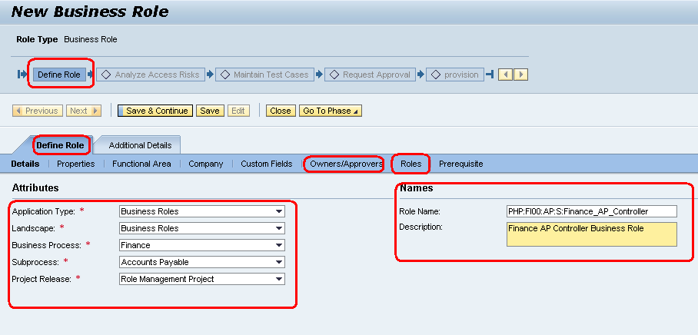

33. User searches for Business Role in GRC system but however he is unable to find out- Explain the reason?

- Check the provisioning status has Production / not.
- Check the role status has complete / not. (After you have done Technical roles imported from plug-in system and added to the Business Role created in GRC system).
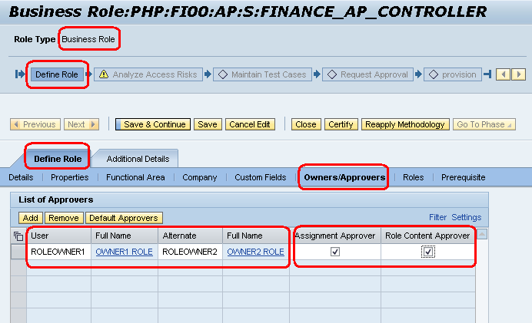

34. How to add or remove Role Owners in BRM?
- They need to be assigned with Approval role name in GRC system.
- Approver’s need to add has assignment approver. (Role content approver is for role methodology)
- Every Business Role needs to have a Primary and Alternative Approvals.
- We don't give Owners to Technical Roles.

35. Role Import explains?
- Role Import can be done for a Single Role or Mass by using TEXT Templates.
- In Risk Analysis we run Repository Object Synch and in BRM we need to bring roles into GRC System using Role Import.

NWBC ------- Access management ------- Role Mass Maintenance ------- Role Import.
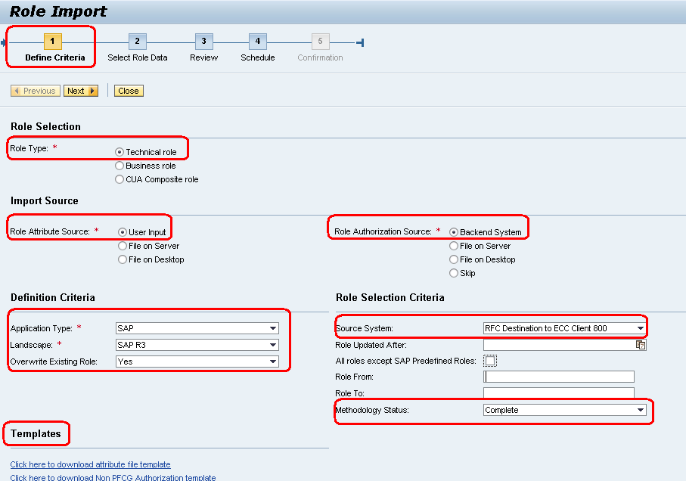
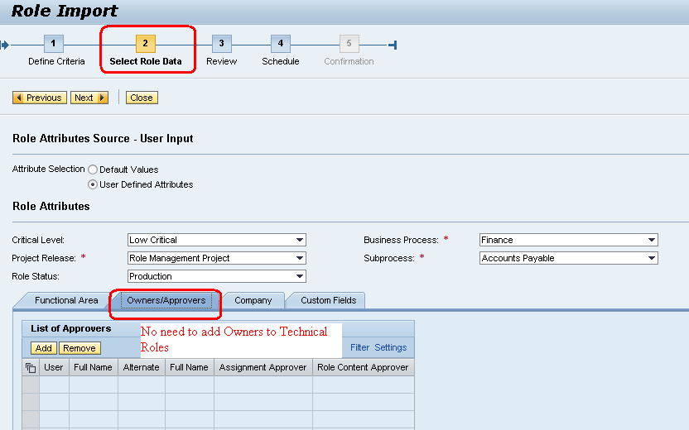

Mandatory Fields:
- Role Methodology Status: Complete.
- Role Status: Production.
- If it is Business Role, then Approvers.
NOTE:
If importing multiple Technical Roles from File on Desktop:
Go to Templates ------ Click here to download attribute file template.

